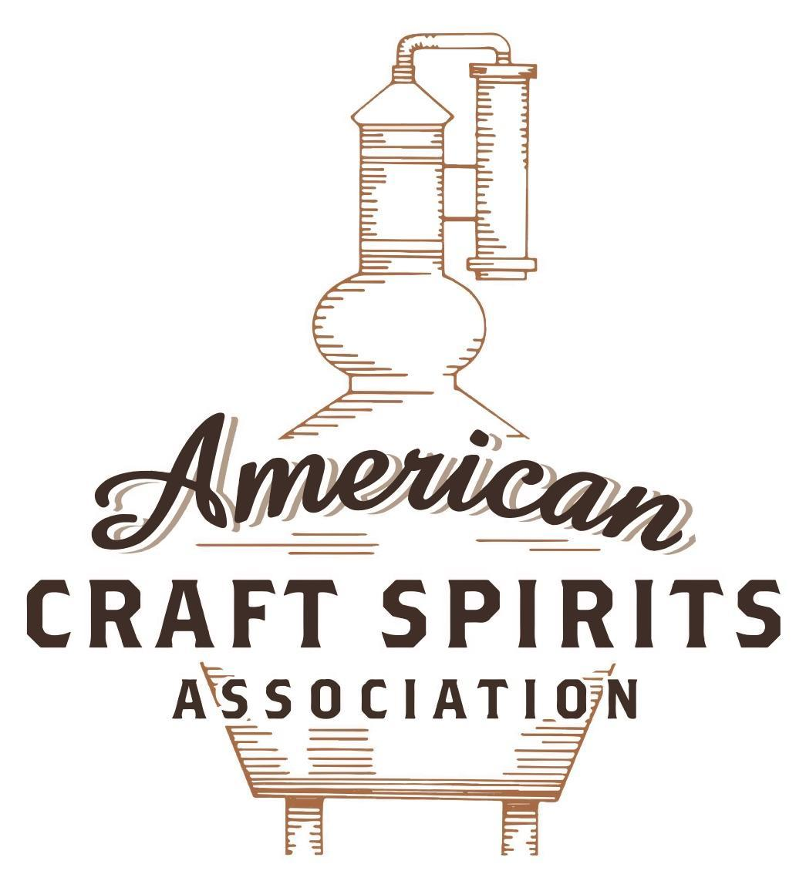
Spirits DtC Shipping Guide

This guide summarizes the direct-to-consumer shipping rules for distilleries in all 50 states and D.C. and also addresses the measures state governments have taken to ease delivery and shipping restrictions during the COVID-19 pandemic.

DtC Quick Guide Comparison

Out-of-State Distilleries  Can Ship Into State? |  |  |  | In-State Distilleries  Can Ship Within State?
State | Yes | No |  | State | Yes | No
AL |  | X |  | AL |  | X
AK | X |  |  | AK | X
AZ | X |  |  | AZ | X
AR |  | X |  | AR |  | X
CA |  | X* |  | CA |  | X*
CO |  | X |  | CO |  | X
CT |  | X* |  | CT |  | X
DE |  | X |  | DE |  | X
DC | X |  |  | DC | X
FL |  | X |  | FL |  | X
GA |  | X |  | GA |  | X
HI |  | X* |  | HI |  | ?*
ID |  | X |  | ID |  | X
IL |  | X* |  | IL |  | X*
IN |  | X |  | IN |  | X
IA |  | X* |  | IA |  | X*
KS |  | X |  | KS |  | X
KY | X |  |  | KY | X
LA |  | X |  | LA |  | X
ME |  | X* |  | ME |  | X*
MD |  | X |  | MD |  | X
MA |  | X |  | MA |  | X
MI |  | X |  | MI |  | X
MN |  | X |  | MN |  | X
MS |  | X |  | MS |  | X
MO |  | X |  | MO |  | X
MT |  | X |  | MT |  | X
NE | X |  |  | NE | X
NV |  | X* |  | NV |  | X
NH | X |  |  | NH |  | X*
NJ |  | X* |  | NJ |  | X*
NM |  | X |  | NM |  | X
NY |  | X* |  | NY |  | X*
NC |  | X |  | NC |  | X
ND | X |  |  | ND | X
OH |  | X |  | OH |  | X
OK |  | X |  | OK |  | X
OR |  | X |  | OR | X
PA |  | X* |  | PA |  | X
RI |  | X* |  | RI |  | X
SC |  | X |  | SC |  | X
SD |  | X |  | SD |  | X
TN |  | X |  | TN |  | X
TX |  | X |  | TX |  | X
UT |  | X |  | UT |  | X
VT |  | X |  | VT |  | X
VA |  | X |  | VA |  | X
WA |  | X* |  | WA | X
WV |  | X* |  | WV |  | X*

WI |  | X |  | WI |  | X
WY |  | X |  | WY |  | X

Notes:
*CA: If passed and signed into law, Senate Bill 620 would allow licensed distilled spirits producers in states other than California and licensed distilled spirits manufacturers or craft distillers in California who obtain distilled spirits direct shipper permits to ship directly to consumers in California
*CT: Consumers with appropriate permit may receive alcohol shipments
*HI: Consumers with appropriate permit may receive alcohol shipments; If passed and signed into law, Senate Bill 65 would allow licensed distilled spirits manufacturers in Hawaii and in states other than Hawaii who obtain direct shipper permits to ship directly to consumers in Hawaii
*IL: If passed and signed into law, Senate Bill 0532 would allow licensed distilled spirits producers in Illinois and in states other than Illinois who obtain distillery shippers’ licenses to ship directly to consumers in Illinois
*IA: If passed and signed into law, House File 639 would allow native distilled spirits manufacturers in Iowa and in states other than Iowa who obtain direct shipper permits to ship directly to consumers in Iowa and to consumers in states other than Iowa
*ME: If passed and signed into law, Legislative Document 1358 would allow distilleries outside of Maine with current manufacturer licenses and distilleries licensed in Maine who obtain spirits direct shipper licenses to ship directly to consumers in Maine
*NJ: (1) If passed and signed into law, Assembly Bill 3167 would allow a craft distillery licensees to ship no more than 9 liters of distilled spirits to a consumer in New Jersey; (2) If passed and signed into law, Senate Bill 3020 would allow craft distillery licensees in New Jersey or in states other than New Jersey to ship no more than 20 liters of distilled spirits to a consumer in New Jersey via common carrier
*NV: Licensed individuals can import one gallon per month of spirits for personal use and the out-of-state supplier must pay excise tax
*NH: If passed and signed into law, Senate Bill 125 would allow licensed liquor manufacturers who obtain direct to consumer shipping permits from the commission to ship directly to consumers in New Hampshire
*NY: Consumer may import up to 90L of liquor per year for personal use without a license; If passed and signed into law, Assembly Bill 3275 would allow licensed liquor manufacturers in states other than New York and licensed distillers and farm distillers in New York to ship no more than thirty-six cases (no more than nine liters per case) of liquor to consumers in New York
*PA: Consumer may place a special liquor order and distiller must ship to a PLCB-operated store
*RI: Distiller can only ship to customer if order was personally placed by customer at distiller's premises
*WA: If passed and signed into law, House Bill 1432 would allow licensed spirits manufacturers in states other than Washington to ship spirits to consumers in Washington
*WV: Distilleries, mini-distilleries, or micro-distilleries licensed in West Virginia or a state other than West Virginia who obtain private direct shipper licenses to ship to a consumer in West Virginia, however the shipments must be made to a retail liquor outlet

WEST VIRGINIA
Shipment Outbound – Silent.
Shipment Inbound – No (W. Va. Code § 60-6-13).
Shipment Intra-state – No, distilleries may only offer liquor for retail sale to customers from the distillery, mini-distillery, or micro-distillery for consumption off premises only (excluding samples) (W. Va. Code § 60-4-3a).
COVID-19 Measures – Relief measures explicitly prohibit distilleries and mini-distilleries from providing home delivery of liquor.
Link: https://abca.wv.gov/Documents/Advisories/Limited%20Outdoor%20Dining%20Area%20Advisory.4th_revised.101220.pdf
Citation (shipment)
West Virginia Code
§ 60-4-3. To whom licensed manufacturer may sell.
A person who is licensed to manufacture alcoholic liquors in this state may sell liquors in this state only to the West Virginia Alcohol Beverage Control Commissioner and to wholesalers and retailers licensed as provided in this chapter: Provided, That a holder of a winery or a farm winery license may sell wines and a holder of a distillery, mini-distillery, or micro-distillery license may sell alcoholic liquors manufactured by it in this state in accordance with the provisions of §60-6-2 of this code. Hours of retail sale by a winery or a farm winery or distillery, mini-distillery or micro-distillery are subject to regulation by the commissioner. A winery, distillery, farm winery, or mini-distillery may sell and ship alcoholic liquors outside of the state subject to provisions of this chapter.
Link: https://www.wvlegislature.gov/wvcode/ChapterEntire.cfm?chap=60&art=4&section=3#4

§ 60-4-3a. Distillery and mini-distillery license to manufacture and sell.
(a) Sales of liquor. — An operator of a distillery, mini-distillery, or micro-distillery may offer liquor for retail sale to customers from the distillery, mini-distillery, or micro-distillery for consumption off premises only. Except for complimentary samples offered pursuant to §60-6-1 of this code, customers may not consume any liquor on the premises of the distillery, mini-distillery, or micro-distillery and except for a distillery, mini-distillery, or micro-distillery that obtains a private manufacturer club license set forth in §60-7-1 et seq. of this code, and a Class A retail dealer license set forth in §11-16-1 et seq. of the code: Provided, That a licensed distillery, mini-distillery, or micro-distillery may offer complimentary samples of alcoholic liquors as authorized this subsection when alcoholic liquors are manufactured by that licensed distillery, mini-distillery, or micro-distillery for consumption on the licensed premises. Notwithstanding any other provision of law to the contrary, a licensed distillery, mini-distillery, or micro-distillery may sell, furnish, and serve alcoholic liquors when licensed accordingly beginning at 6:00 a.m. unless otherwise determined by the residents of the county pursuant to §7-1-3ss of this code.
(b) Retail off-premises consumption sales. — Every licensed distillery, mini-distillery, or micro-distillery shall comply with the provisions of §60-3A-9, §60-3A-11, §60-3A-13, §60-3A-16, §60-3A-17, §60-3A-18, §60-3A-19, §60-3A-22, §60-3A-23, §60-3A-24, §60-3A-25, and §60-3A-26 of this code, and the provisions of §60-3-1 et. seq. and §60-4-1 et. seq., of this code, applicable to liquor retailers and distillers.
(e) Limitations on licensees. — A distillery, mini-distillery, or micro-distillery may not sell more than 3,000 gallons of product at the distillery, mini-distillery, or micro-distillery location during the initial 24 month period of licensure. The distillery, mini-distillery, or micro-distillery may increase sales at the distillery, mini-distillery, micro-distillery location by 2,000 gallons following the initial 24 month period of licensure and may increase sales at the distillery, mini-distillery, or micro-distillery location each subsequent 24 month period by 2,000 gallons, not to exceed 10,000 gallons a year of total sales at the distillery, mini-distillery, or micro-distillery location. No licensed mini-distillery may produce more than 50,000 gallons per calendar year at the mini-distillery location. A licensed micro-distillery may not produce more than 10,000 gallons per calendar year at the micro-distillery location. The commissioner may issue more than one distillery or mini-distillery license to a single person or entity and a person may hold both a distillery and a mini-distillery license. The owners of a licensed distillery, mini-distillery, or micro-distillery may operate a winery, farm winery, brewery, or as a resident brewer as otherwise specified in the code.
Link: https://www.wvlegislature.gov/wvcode/ChapterEntire.cfm?chap=60&art=4&section=3A#4
§ 60-6-13. Restrictions on importing into, and transporting liquors in state.
Except as permitted by section six of this article and article eight of this chapter, a person shall not import into, or transport in this state, any alcoholic liquors, unless it is:
(3) Transported into the state or through the state to persons outside the state upon transportation permits issued by the commissioner.
Link: https://www.wvlegislature.gov/wvcode/ChapterEntire.cfm?chap=60&art=6&section=13#6

The American Craft Spirits Association (ACSA) is working diligently to give our members and industry partners relevant, current updates on statutes and regulations impacting production, sale and distribution of spirits. With the declaration of the novel coronavirus (COVID-19) in early 2020, many states have issued temporary policy changes or longer-term modernization of alcohol beverage laws. State statutes, regulations created by the state alcohol regulatory authority, as well as any other relevant guidance provided by such authorities (such as advisories, opinions, bulletins, etc.) were reviewed in creation of this document. No city or county ordinances were reviewed. Distillers should be aware that even in states where direct shipping is permissible, always remember to avoid shipping to dry counties. Please consult with your state guild or alcohol beverage authority for the most up-to-date information. This content is intended for educational and informational purposes only. ACSA's pro bono law firm of Malkin Law P.A. provided the core content found in this comprehensive overview of the spirits distribution after COVID-19. It was completed in August 2021 and will be updated regularly. If you have updates you would like to provide, please send to legislation@americancraftspirits.org or directly to the law firm at: ryan@malkin.law / malkin.law. Thank you.
H.B. 2025, signed and enacted into law on May 20, 2021, allows a distillery, mini-distillery, or micro-distillery whose licensed premises is in West Virginia to obtain a private direct shipper license to ship from its primary place of business directly to a consumer in another state who is at least 21 years of age for personal consumption via a mail shipping carrier subject to the recipient state’s requirements and laws. A private direct shipper licensee may not ship more than two bottles of liquor per month to a retail liquor outlet for pickup by a consumer. The combined fluid volume of both bottles may not exceed three liters. Link: http://www.wvlegislature.gov/Bill_Status/bills_text.cfm?billdoc=HB2025%20SUB%20ENR.htm&yr=2021&sesstype=RS&i=2025
H.B. 2025, signed and enacted into law on May 20, 2021, allows a distillery, mini-distillery, or micro-distillery whose licensed premises is in a state other than West Virginia to obtain a private direct shipper license to ship directly from the licensee’s primary place of distilling to a consumer who is at least 21 years of age for personal consumption via a mail shipping carrier. However, the shipments must be delivered to a retail liquor outlet in the market zone in which the consumer resides and cannot be shipped to areas designated as “dry” areas. A private direct shipper licensee may not ship more than two bottles of liquor per month to a retail liquor outlet for pickup by a consumer. The combined fluid volume of both bottles may not exceed three liters. Link: http://www.wvlegislature.gov/Bill_Status/bills_text.cfm?billdoc=HB2025%20SUB%20ENR.htm&yr=2021&sesstype=RS&i=2025
H.B. 2025, signed and enacted into law on May 20, 2021, allows a distillery, mini-distillery, or micro-distillery whose licensed premises is in West Virginia to obtain a private direct shipper license to ship directly from the licensee’s primary place of distilling to a consumer who is at least 21 years of age for personal consumption via a mail shipping carrier. However, the shipments must be delivered to a retail liquor outlet in the market zone in which the consumer resides and cannot be shipped to areas designated as “dry” areas. A private direct shipper licensee may not ship more than two bottles of liquor per month to a retail liquor outlet for pickup by a consumer. The combined fluid volume of both bottles may not exceed three liters. Link: http://www.wvlegislature.gov/Bill_Status/bills_text.cfm?billdoc=HB2025%20SUB%20ENR.htm&yr=2021&sesstype=RS&i=2025

